Power BI Report Technical Documentation Template
1. Report Overview
- Report Name: IAM Ops Dashboard
- Business Owner: Susie Barett, Erica Garcia
- Created By: Sri Vinay Reddy Surabi
- Purpose / Description:
- Target Audience:
2. Data Sources
- Source System(s): vw_SN_sc_Escalation_IamOps_Dashboard
- Connection Type (Direct Query / Import / Live Connection): Import
- Database Name / Server Name: ServicePerf_DW database
- Tables / Views Used: 1
- Data Gateway Used (if applicable): No
- Credentials / Authentication Method: username: IAM_ServiceNow_Tableau
Password: iamrocks!!
3. Data Model
- Fact Tables: 1
- Dimension Tables:
- Relationships:
- Data Volume / Size: 19.3 million records
- Data Refresh Frequency: Daily
4. KPIs and Metrics
- Service level targets: it is grouping of certain value from Service Level Target column below is the DAX formula for the service level target grouping column
Service Level Target (group)_2 =
SWITCH(TRUE(),
'Service Now'[Service Level Target] IN {
"Day One: SailPoint New Hire - Lawson",
"Day One: SailPoint New Hire - Non-Lawson",
"Exchange",
"Exchange.ActiveSync",
"Exchange.Lync",
"Non-Lawson Base Access",
"Non-Lawson Base Multi",
"SailPoint Modify Caregiver",
"SailPoint New Hire",
"SailPoint New Hire - Employee",
"SailPoint New Hire - Lawson",
"SailPoint New Hire - Non-Employee",
"SailPoint New Hire - Non-Lawson",
"SailPoint Persona Edit",
"SailPoint Review Duplicate",
"SailPoint Review Duplicate - Employee",
"SailPoint Review Duplicate - Lawson",
"SailPoint Review Duplicate - Non-Employee",
"SailPoint Termination",
"Termination"
},"1 Day"
,'Service Now'[Service Level Target] IN {
"Access Extension",
"Access to Shared Mailbox",
"CC Epic Hyperspace",
"Capacity Management",
"Conference Room",
"Dameware",
"Demographics",
"Distribution List",
"Electronic Forms Repository",
"Exchange.Mailbox Size Adjustment",
"Extension",
"Extensions",
"From ISRC",
"Grant Application Access",
"Group Mailbox",
"HPOVSD ISRC",
"HPOVSD Migrated",
"ICFWIN",
"IDM Deletion Event",
"IS to IS Request",
"IS to IAM Request",
"Job Role Template",
"Local Admin Rights",
"Meditech",
"Migrated Ticket",
"Network Drive Access",
"New Access Request",
"New Access Request - Employee",
"New Access Request - Non-Employee",
"New Access Request - Provider",
"New Access Request - Student",
"New Access Request - Unclassified",
"New Access Request - Vendor",
"Other",
"PHS Epic Carelink",
"PHS Epic Hyperspace",
"Remote Access",
"Request Submitted as Incident",
"RightFax",
"SHS Epic Carelink",
"SHS Epic Hyperspace",
"SHS HPOVSD Migrated",
"SHS ISRC",
"Shared Folder",
"Shared Mailbox",
"Shared Outlook Resource",
"Swedish ISRC",
"Synapse",
"TAGAA"},"14 day",
'Service Now'[Service Level Target] in { "Incident"} ,"Incident"--,'IAM Ops SNow'[Service Level Targets]

- Service Level Target is a conditional column created by consolidating the Request Area Detail Master, Request Area, and IAM Work Categories. below is DAX logic
Service Level Target =
SWITCH(TRUE(),
//Request Area Detail Master
[Ticket Type] = "sc_task" && CONTAINSSTRING([Request Item Category], "SailPoint Termination"), "SailPoint Termination",
[Ticket Type] = "sc_task" && CONTAINSSTRING([Request Item Category], "SailPoint New SJH Registry") && CONTAINSSTRING([Ticket short description], "SailPoint Termination"), "SailPoint Termination",
[Ticket Type] = "sc_task" && CONTAINSSTRING([Request Item Category], "SailPoint New Hire") && CONTAINSSTRING([Ticket short description], "Account Creation"), "SailPoint New Hire - Lawson",
[Ticket Type] = "sc_task" && CONTAINSSTRING([Request Item Category], "SailPoint New Hire") && CONTAINSSTRING([Ticket short description], "Identity Creation"), "SailPoint New Hire - Lawson",
[Ticket Type] = "sc_task" && CONTAINSSTRING([Request Item Category], "IdentityIQ Automated Request") && CONTAINSSTRING([Ticket short description], "Employee"), "Day One: SailPoint New Hire - Lawson",
[Ticket Type] = "sc_task" && CONTAINSSTRING([Request Item Category], "SailPoint New Non-Employee") && CONTAINSSTRING([Ticket short description], "Account Creation"), "SailPoint New Hire - Non-Lawson",
[Ticket Type] = "sc_task" && CONTAINSSTRING([Request Item Category], "SailPoint New Non-Employee") && CONTAINSSTRING([Ticket short description], "Identity Creation"), "SailPoint New Hire - Non-Lawson",
[Ticket Type] = "sc_task" && CONTAINSSTRING([Request Item Category], "SailPoint New SJH Registry") && CONTAINSSTRING([Ticket short description], "Identity Creation"), "SailPoint New Hire - Non-Lawson",
[Ticket Type] = "sc_task" && CONTAINSSTRING([Request Item Category], "SailPoint New Provider") && CONTAINSSTRING([Ticket short description], "Identity Creation"), "SailPoint New Hire - Non-Lawson",
[Ticket Type] = "sc_task" && CONTAINSSTRING([Request Item Category], "IdentityIQ Automated Request"), "Day One: SailPoint New Hire - Non-Lawson",
[Ticket Type] = "sc_task" && CONTAINSSTRING([Request Item Category], "SailPoint New Hire") && CONTAINSSTRING([Ticket short description], "Duplicate"), "SailPoint Review Duplicate",
[Ticket Type] = "sc_task" && CONTAINSSTRING([Request Item Category], "SailPoint New Non-Employee") && CONTAINSSTRING([Ticket short description], "Duplicate"), "SailPoint Review Duplicate",
[Ticket Type] = "sc_task" && CONTAINSSTRING([Request Item Category], "SailPoint New SJH Registry") && CONTAINSSTRING([Ticket short description], "Duplicate"), "SailPoint Review Duplicate",
[Ticket Type] = "sc_task" && CONTAINSSTRING([Request Item Category], "SailPoint New Provider") && CONTAINSSTRING([Ticket short description], "Duplicate"), "SailPoint Review Duplicate",
[Ticket Type] = "sc_task" && CONTAINSSTRING([Request Item Category], "SailPoint Modify Caregiver") && CONTAINSSTRING([Ticket short description], "Persona Edit"), "SailPoint Persona Edit",
[Ticket Type] = "sc_task" && CONTAINSSTRING([Request Item Category], "SailPoint New SJH Registry") && CONTAINSSTRING([Ticket short description], "Persona Edit"), "SailPoint Persona Edit",
[Ticket Type] = "sc_task" && CONTAINSSTRING([Request Item Category], "SailPoint Modify Caregiver"), "SailPoint Modify Caregiver",
[Ticket Type] = "sc_task" && CONTAINSSTRING([Request Item Category], "SailPoint New SJH Registry") && CONTAINSSTRING([Ticket short description], "Persona Modification"), "SailPoint Modify Caregiver",
[Ticket Type] = "sc_task" && CONTAINSSTRING([Request Item Category], "SailPoint New Hire"), "SailPoint New Hire - Lawson",
[Ticket Type] = "sc_task" && CONTAINSSTRING([Request Item Category], "SailPoint New Non-Employee"), "SailPoint New Hire - Non-Lawson",

//SailPoint Manual
[Ticket Type] = "sc_task" && CONTAINSSTRING([Ticket short description], "Term"), "Termination",

//Epic
[Ticket Type] = "sc_task" && CONTAINSSTRING([Ticket short description], "EPIC-ORCA"), "Epic Hyperspace-ORCA",
[Ticket Type] = "sc_task" && CONTAINSSTRING([Ticket short description], "EPIC-WAMT"), "Epic Hyperspace-WAMT",
[Ticket Type] = "sc_task" && CONTAINSSTRING([Ticket short description], "EPIC-AK"), "Epic Hyperspace-AK",
[Ticket Type] = "sc_task" && CONTAINSSTRING([Ticket short description], "EPIC-KADLEC"), "Epic Hyperspace-KADLEC",
[Ticket Type] = "sc_task" && CONTAINSSTRING([Ticket short description], "EPIC-SWE"), "Epic Hyperspace-SWE",
[Ticket Type] = "sc_task" && CONTAINSSTRING([Ticket short description], "EPIC-PACMED"), "Epic Hyperspace-PACMED",
[Ticket Type] = "sc_task" && CONTAINSSTRING([Ticket short description], "Grant template"), "Epic Hyperspace",
[Ticket Type] = "sc_task" && CONTAINSSTRING([Ticket short description], "Epic Hyperspace-ORCA"), "Epic Hyperspace-ORCA",
[Ticket Type] = "sc_task" && CONTAINSSTRING([Ticket short description], "Epic"), COALESCE([Configuration Item],[Catalog Item Name],[Ticket short description]),

//Meditech
[Ticket Type] = "sc_task" && CONTAINSSTRING([Ticket short description], "Meditech"), "Meditech Access Request",
[Ticket Type] = "sc_task" && CONTAINSSTRING([Ticket short description], "Meditech"), [Configuration Item],

//Collaboration
[Ticket Type] = "sc_task" && CONTAINSSTRING([Configuration Item], "Exchange"), [Configuration Item],
[Ticket Type] = "sc_task" && CONTAINSSTRING([Configuration Item], "Teams"), [Configuration Item],
[Ticket Type] = "sc_task" && CONTAINSSTRING([Configuration Item], "OneDrive"), [Configuration Item],
[Ticket Type] = "sc_task" && CONTAINSSTRING([Configuration Item], "Office"), [Configuration Item],
[Ticket Type] = "sc_task" && CONTAINSSTRING([Configuration Item], "Email"), [Configuration Item],
[Ticket Type] = "sc_task" && CONTAINSSTRING([Catalog Item Name], "Exchange"), [Catalog Item Name],
[Ticket Type] = "sc_task" && CONTAINSSTRING([Catalog Item Name], "Teams"), [Catalog Item Name],
[Ticket Type] = "sc_task" && CONTAINSSTRING([Catalog Item Name], "OneDrive"), [Catalog Item Name],
[Ticket Type] = "sc_task" && CONTAINSSTRING([Catalog Item Name], "Office"), [Catalog Item Name],
[Ticket Type] = "sc_task" && CONTAINSSTRING([Catalog Item Name], "Email"), [Catalog Item Name],
[Ticket Type] = "sc_task" && CONTAINSSTRING([Request Ticket Summary], "shared mailbox"), "Shared Mailbox",
[Ticket Type] = "sc_task" && CONTAINSSTRING([Request Ticket Summary], "Distribution List"), "Distribution List",

//IDM Core
[Ticket Type] = "sc_task" && CONTAINSSTRING([Ticket short description], "Local Admin Rights"), "Local Admin Rights",
[Ticket Type] = "sc_task" && CONTAINSSTRING([Ticket short description], "Extend network access"), "Access Extension",
[Ticket Type] = "sc_task" && CONTAINSSTRING([Request Ticket Summary], "I can't find what I need"), "ICFWIN",
[Ticket Type] = "sc_task" && CONTAINSSTRING([Ticket short description], "Network Drive Access"), "Network Drive Access",
[Ticket Type] = "sc_task" && CONTAINSSTRING([Catalog Item Name], "Remote Access"), "Remote Access Requests",
[Ticket Type] = "sc_task" && CONTAINSSTRING([Ticket short description], "Remote Access"), "Remote Access Requests",
[Ticket Type] = "sc_task" && CONTAINSSTRING([Request Ticket Summary], "Remote Access"), "Remote Access Requests",

//ICFWIN
[Ticket Type] = "sc_task" && CONTAINSSTRING([Request Item Ticket Summary], "Please use this request if you cannot find what you are looking for."), "ICFWIN",
[Ticket Type] = "sc_task" && CONTAINSSTRING([Request Item Ticket Summary], "Application Access Request"), [Configuration Item],

//IS to IS or IS to IAM
[Ticket Type] = "sc_task" && CONTAINSSTRING([Request Ticket Summary], "IS to IS request"), "IS to IS Request",
[Ticket Type] = "sc_task" && CONTAINSSTRING([Request Item Ticket Summary], "IS to IS request"), "IS to IS Request",
[Ticket Type] = "sc_task" && CONTAINSSTRING([Ticket short description], "IS to IAM request"), [Ticket short description],
[Ticket Type] = "sc_task" && CONTAINSSTRING([Request Item Ticket Summary], "IS to IAM request"), [Ticket short description],

//Incident and Request Area Detail
[System2.SNow] = "ServiceNow" && ([Ticket Type] = "Incident" || [Ticket Type] = "Incident"), "Incident",

//IAM Work Queues(Request Area)
[Ticket Type] = "sc_task" && CONTAINSSTRING([Request Item Category], "SailPoint Termination"), "SailPoint Termination",
[Ticket Type] = "sc_task" && CONTAINSSTRING([Request Item Category], "SailPoint New SJH Registry") && CONTAINSSTRING([Ticket short description], "SailPoint Termination"), "SailPoint Termination",
[Ticket Type] = "sc_task" && CONTAINSSTRING([Request Item Category], "SailPoint New Hire") && CONTAINSSTRING([Ticket short description], "Account Creation"), "SailPoint New Hire - Lawson",
[Ticket Type] = "sc_task" && CONTAINSSTRING([Request Item Category], "SailPoint New Hire") && CONTAINSSTRING([Ticket short description], "Identity Creation"), "SailPoint New Hire - Lawson",
[Ticket Type] = "sc_task" && CONTAINSSTRING([Request Item Category], "IdentityIQ Automated Request") && CONTAINSSTRING([Ticket short description], "Employee"), "Day One: SailPoint New Hire - Lawson",
[Ticket Type] = "sc_task" && CONTAINSSTRING([Request Item Category], "SailPoint New Non-Employee") && CONTAINSSTRING([Ticket short description], "Account Creation"), "SailPoint New Hire - Non-Lawson",
[Ticket Type] = "sc_task" && CONTAINSSTRING([Request Item Category], "SailPoint New Non-Employee") && CONTAINSSTRING([Ticket short description], "Identity Creation"), "SailPoint New Hire - Non-Lawson",
[Ticket Type] = "sc_task" && CONTAINSSTRING([Request Item Category], "SailPoint New SJH Registry") && CONTAINSSTRING([Ticket short description], "Identity Creation"), "SailPoint New Hire - Non-Lawson",
[Ticket Type] = "sc_task" && CONTAINSSTRING([Request Item Category], "SailPoint New Provider") && CONTAINSSTRING([Ticket short description], "Identity Creation"), "SailPoint New Hire - Non-Lawson",
[Ticket Type] = "sc_task" && CONTAINSSTRING([Request Item Category], "IdentityIQ Automated Request"), "Day One: SailPoint New Hire - Non-Lawson",
[Ticket Type] = "sc_task" && CONTAINSSTRING([Request Item Category], "SailPoint New Hire") && CONTAINSSTRING([Ticket short description], "Duplicate"), "SailPoint Review Duplicate",
[Ticket Type] = "sc_task" && CONTAINSSTRING([Request Item Category], "SailPoint New Non-Employee") && CONTAINSSTRING([Ticket short description], "Duplicate"), "SailPoint Review Duplicate",
[Ticket Type] = "sc_task" && CONTAINSSTRING([Request Item Category], "SailPoint New SJH Registry") && CONTAINSSTRING([Ticket short description], "Duplicate"), "SailPoint Review Duplicate",
[Ticket Type] = "sc_task" && CONTAINSSTRING([Request Item Category], "SailPoint New Provider") && CONTAINSSTRING([Ticket short description], "Duplicate"), "SailPoint Review Duplicate",
[Ticket Type] = "sc_task" && CONTAINSSTRING([Request Item Category], "SailPoint Modify Caregiver") && CONTAINSSTRING([Ticket short description], "Persona Edit"), "SailPoint Persona Edit",
[Ticket Type] = "sc_task" && CONTAINSSTRING([Request Item Category], "SailPoint New SJH Registry") && CONTAINSSTRING([Ticket short description], "Persona Edit"), "SailPoint Persona Edit",
[Ticket Type] = "sc_task" && CONTAINSSTRING([Request Item Category], "SailPoint Modify Caregiver"), "SailPoint Modify Caregiver",

[Ticket Type] = "sc_task" && CONTAINSSTRING([Request Item Category], "SailPoint New SJH Registry") && CONTAINSSTRING([Ticket short description], "Persona Modification"), "SailPoint Modify Caregiver",
[Ticket Type] = "sc_task" && CONTAINSSTRING([Request Item Category], "SailPoint New Hire"), "SailPoint New Hire - Lawson",
[Ticket Type] = "sc_task" && CONTAINSSTRING([Request Item Category], "SailPoint New Non-Employee"), "SailPoint New Hire - Non-Lawson",
[Ticket Type] = "sc_task" && CONTAINSSTRING([Ticket short description], "Remote Access"), "Remote Access",
[Ticket Type] = "sc_task" && CONTAINSSTRING([Request Ticket Summary], "Remote Access"), "Remote Access",
[Ticket Type] = "sc_task" && CONTAINSSTRING([Ticket short description], "Grant template"), "PHS Epic Hyperspace",
[Ticket Type] = "sc_task" && CONTAINSSTRING([Request Ticket Summary], "EPIC-ORCA"), "PHS Epic Hyperspace",
[Ticket Type] = "sc_task" && CONTAINSSTRING([Request Ticket Summary], "EPIC-WAMT"), "PHS Epic Hyperspace",
[Ticket Type] = "sc_task" && CONTAINSSTRING([Ticket short description], "distribution list or mailbox"), "Shared Mailbox",
[Ticket Type] = "sc_task" && CONTAINSSTRING([Ticket short description], "shared mailbox"), "Shared Mailbox",
[Ticket Type] = "sc_task" && CONTAINSSTRING([Request Ticket Summary], "shared mailbox"), "Shared Mailbox",
[Ticket Type] = "sc_task" && CONTAINSSTRING([Ticket short description], "DL action to take"), "Distribution List",
[Ticket Type] = "sc_task" && CONTAINSSTRING([Request Ticket Summary], "Distribution List"), "Distribution List",
[Ticket Type] = "sc_task" && CONTAINSSTRING([Ticket short description], "Network Drive Access"), "Network Drive Access",
[Ticket Type] = "sc_task" && CONTAINSSTRING([Ticket short description], "Mailbox Size Adjustment"), "Exchange.Mailbox Size Adjustment",
[Ticket Type] = "sc_task" && CONTAINSSTRING([Ticket short description], "Extend network access"), "Access Extension",
[Ticket Type] = "sc_task" && CONTAINSSTRING([Request Ticket Summary], "I can't find what I need"), "ICFWIN",
[Ticket Type] = "sc_task" && CONTAINSSTRING([Ticket short description], "Provision ActiveSync"), "Exchange.ActiveSync",
[Ticket Type] = "sc_task" && CONTAINSSTRING([Ticket short description], "Enable ActiveSync"), "Exchange.ActiveSync",
[Ticket Type] = "sc_task" && CONTAINSSTRING([Ticket short description], "Enable Lync"), "Exchange.Lync",
[Ticket Type] = "sc_task" && CONTAINSSTRING([Ticket short description], "Exchange-PHS"), "Exchange",
[Ticket Type] = "sc_task" && CONTAINSSTRING([Ticket short description], "Local Admin Rights"), "Local Admin Rights",
[Ticket Type] = "sc_task" && CONTAINSSTRING([Ticket short description], "Epic Hyperspace-ORCA"), "PHS Epic Hyperspace",
[Ticket Type] = "sc_task" && CONTAINSSTRING([Ticket short description], "Application Access Request"), "Grant Application Access",
[Ticket Type] = "sc_task" && CONTAINSSTRING([Ticket short description], "Please provide access to"), "Grant Application Access",
[Ticket Type] = "sc_task" && CONTAINSSTRING([Ticket short description], "add access"), "Grant Application Access",
[Ticket Type] = "sc_task" && CONTAINSSTRING([Ticket short description], "access request"), "Grant Application Access",
[Ticket Type] = "sc_task" && CONTAINSSTRING([Request Item Ticket Summary], "Please use this request if you cannot find what you are looking for."), "ICFWIN",
[Ticket Type] = "sc_task" && CONTAINSSTRING([Request Item Ticket Summary], "Application Access Request"), "Grant Application Access",
[Ticket Type] = "sc_task" && CONTAINSSTRING([Ticket short description], "Term"), "Termination",
[Ticket Type] = "sc_task" && CONTAINSSTRING([Request Ticket Summary], "IS to IS request"), "IS to IS request",
[Ticket Type] = "sc_task" && CONTAINSSTRING([Request Item Ticket Summary], "IS to IS request"), "IS to IS request",
[Ticket Type] = "sc_task" && CONTAINSSTRING([Ticket short description], "IS to IAM request"), "IS to IAM request",
[Ticket Type] = "sc_task" && CONTAINSSTRING([Request Item Ticket Summary], "IS to IAM request"), "IS to IAM request",
[System2.SNow] = "ServiceNow" && [Ticket Type] = "Incident", "Incident",

//IAM Work Categories =
CONTAINSSTRING([Request Area.Detail Master], "Day One: SailPoint"), "SailPoint - Automated",
[Ticket Type] = "sc_task" && CONTAINSSTRING([Request Area.Detail Master], "SailPoint"), "SailPoint - Manual",
CONTAINSSTRING([Request Area.Detail Master], "Termination"), "SailPoint - Manual",
CONTAINSSTRING([Request Area.Detail Master], "Epic"), "Epic",
CONTAINSSTRING([Request Area.Detail Master], "Healthcare Information Exchange"), "Grant Application Access",
CONTAINSSTRING([Request Area.Detail Master], "Teams"), "Collaboration",
CONTAINSSTRING([Request Area.Detail Master], "Sharepoint"), "Collaboration",
CONTAINSSTRING([Request Area.Detail Master], "Exchange"), "Collaboration",
CONTAINSSTRING([Request Area.Detail Master], "Lync"), "Collaboration",
CONTAINSSTRING([Request Area.Detail Master], "Onedrive"), "Collaboration",
CONTAINSSTRING([Request Area.Detail Master], "Email"), "Collaboration",
CONTAINSSTRING([Request Area.Detail Master], "Office"), "Collaboration",
CONTAINSSTRING([Request Area.Detail Master], "Shared Mailbox"), "Collaboration",
CONTAINSSTRING([Request Area.Detail Master], "secure mobile"), "Collaboration",
CONTAINSSTRING([Request Area.Detail Master], "distribution list"), "Collaboration",
CONTAINSSTRING([Request Area.Detail Master], "DL Action"), "Collaboration",
CONTAINSSTRING([Request Area.Detail Master], "IS to IAM"), "Generic",
CONTAINSSTRING([Request Area.Detail Master], "IS to IS"), "Generic",
CONTAINSSTRING([Request Area.Detail Master], "find what I need"), "Generic",
CONTAINSSTRING([Request Area.Detail Master], "Consultation"), "Generic",
CONTAINSSTRING([Request Area.Detail Master], "remote"), "IDM Core",
CONTAINSSTRING([Request Area.Detail Master], "Access"), "Grant Application Access",
CONTAINSSTRING([Request Area.Detail Master], "Meditech"), "Grant Application Access",
CONTAINSSTRING([Request Area.Detail Master], "EPCS"), "Grant Application Access",
CONTAINSSTRING([Request Area.Detail Master], "Firewall"), "Grant Application Access",
CONTAINSSTRING([Catalog Item Name], "sc_task"), "Grant Application Access",
CONTAINSSTRING([Catalog Item Name], "Access"), "Grant Application Access",
CONTAINSSTRING([Catalog Item Name], "find what I need"), "Grant Application Access",
CONTAINSSTRING([Ticket short description], "Add Access"), "Grant Application Access",
[Ticket Type] = "Incident", "Incident",
//Other
COALESCE([Configuration Item], COALESCE([Catalog Item Name], [Ticket short description]))
)

- IAM Work Categories: This is a conditional column based on Request Area. Detail Master, Catalog Item Name, Ticket Short Description. Below is the DAX formula
IAM Work Categories =
Switch(
TRUE(),
CONTAINSSTRING('Service Now'[Request Area.Detail Master],"Day One: SailPoint"), "SailPoint - Automated",
'Service Now' [Ticket Type] = "Request" && CONTAINSSTRING('Service Now'[Request Area.Detail Master], "SailPoint"), "SailPoint - Manual",

CONTAINSSTRING('Service Now'[Request Area.Detail Master], "Termination"), "SailPoint - Manual",
CONTAINSSTRING('Service Now'[Request Area.Detail Master], "Epic"), "Epic",
CONTAINSSTRING('Service Now'[Request Area.Detail Master], "Healthcare Information Exchange"), "Grant Application Access",
CONTAINSSTRING('Service Now'[Request Area.Detail Master], "Teams"), "Collaboration",
CONTAINSSTRING('Service Now'[Request Area.Detail Master], "Sharepoint"), "Collaboration",
CONTAINSSTRING('Service Now'[Request Area.Detail Master], "Exchange"), "Collaboration",
CONTAINSSTRING('Service Now'[Request Area.Detail Master], "Lync"), "Collaboration",
CONTAINSSTRING('Service Now'[Request Area.Detail Master], "Onedrive"), "Collaboration",
CONTAINSSTRING('Service Now'[Request Area.Detail Master], "Email"), "Collaboration",
CONTAINSSTRING('Service Now'[Request Area.Detail Master], "Office"), "Collaboration",
CONTAINSSTRING('Service Now'[Request Area.Detail Master], "Shared Mailbox"), "Collaboration",
CONTAINSSTRING('Service Now'[Request Area.Detail Master], "secure mobile"), "Collaboration",
CONTAINSSTRING('Service Now'[Request Area.Detail Master], "distribution list"), "Collaboration",
CONTAINSSTRING('Service Now'[Request Area.Detail Master], "DL Action"), "Collaboration",
CONTAINSSTRING('Service Now'[Request Area.Detail Master], "IS to IAM"), "Generic",
CONTAINSSTRING('Service Now'[Request Area.Detail Master], "IS to IS"), "Generic",
CONTAINSSTRING('Service Now'[Request Area.Detail Master], "find what I need"), "Generic",
CONTAINSSTRING('Service Now'[Request Area.Detail Master], "Consultation"), "Generic",
CONTAINSSTRING('Service Now'[Request Area.Detail Master], "remote"), "IDM Core",
CONTAINSSTRING('Service Now'[Request Area.Detail Master], "Access"), "Grant Application Access",
CONTAINSSTRING('Service Now'[Request Area.Detail Master], "Meditech"), "Grant Application Access",
CONTAINSSTRING('Service Now'[Request Area.Detail Master], "EPCS"), "Grant Application Access",
CONTAINSSTRING('Service Now'[Request Area.Detail Master], "Firewall"), "Grant Application Access",
CONTAINSSTRING('Service Now'[Catalog Item Name], "Request"), "Grant Application Access",
CONTAINSSTRING('Service Now'[Catalog Item Name], "Access"), "Grant Application Access",
CONTAINSSTRING('Service Now'[Catalog Item Name], "find what I need"), "Grant Application Access",
CONTAINSSTRING('Service Now'[Ticket Short Description], "Add Access"), "Grant Application Access",
'Service Now'[Ticket Type] = "Incident", "Incident",
"Other"
)

- Request Area. Detail Master: it is created based on the Request Item Category, Ticket Short Description, Configuration Item, Catalog Item Name, Request Ticket Summary, System2.Snow, and Ticket Type.
Request Area.Detail Master =
SWITCH(
TRUE(),
//Sailpoint
'Service Now'[Ticket Type] = "sc_task" && CONTAINSSTRING([Request Item Category], "SailPoint Termination"), "SailPoint Termination",
'Service Now'[Ticket Type] = "sc_task" && CONTAINSSTRING([Request Item Category], "SailPoint New SJH Registry") && CONTAINSSTRING([Ticket Short Description], "SailPoint Termination"), "SailPoint Termination",
'Service Now'[Ticket Type] = "sc_task" && CONTAINSSTRING([Request Item Category], "SailPoint New Hire") && CONTAINSSTRING([Ticket Short Description], "Account Creation"), "SailPoint New Hire - Lawson",
'Service Now'[Ticket Type] = "sc_task" && CONTAINSSTRING([Request Item Category], "SailPoint New Hire") && CONTAINSSTRING([Ticket Short Description], "Identity Creation"), "SailPoint New Hire - Lawson",
'Service Now'[Ticket Type] = "sc_task" && CONTAINSSTRING([Request Item Category], "IdentityIQ Automated Request") && CONTAINSSTRING([Ticket Short Description], "Employee"), "Day One: SailPoint New Hire - Lawson",
'Service Now'[Ticket Type] = "sc_task" && CONTAINSSTRING([Request Item Category], "SailPoint New Non-Employee") && CONTAINSSTRING([Ticket Short Description], "Account Creation"), "SailPoint New Hire - Non-Lawson",
'Service Now'[Ticket Type] = "sc_task" && CONTAINSSTRING([Request Item Category], "SailPoint New Non-Employee") && CONTAINSSTRING([Ticket Short Description], "Identity Creation"), "SailPoint New Hire - Non-Lawson",
'Service Now'[Ticket Type] = "sc_task" && CONTAINSSTRING([Request Item Category], "SailPoint New SJH Registry") && CONTAINSSTRING([Ticket Short Description], "Identity Creation"), "SailPoint New Hire - Non-Lawson",
'Service Now'[Ticket Type] = "sc_task" && CONTAINSSTRING([Request Item Category], "SailPoint New Provider") && CONTAINSSTRING([Ticket Short Description], "Identity Creation"), "SailPoint New Hire - Non-Lawson",
'Service Now'[Ticket Type] = "sc_task" && CONTAINSSTRING([Request Item Category], "IdentityIQ Automated Request"), "Day One: SailPoint New Hire - Non-Lawson",
'Service Now'[Ticket Type] = "sc_task" && CONTAINSSTRING([Request Item Category], "SailPoint New Hire") && CONTAINSSTRING([Ticket Short Description], "Duplicate"), "SailPoint Review Duplicate",
'Service Now'[Ticket Type] = "sc_task" && CONTAINSSTRING([Request Item Category], "SailPoint New Non-Employee") && CONTAINSSTRING([Ticket Short Description], "Duplicate"), "SailPoint Review Duplicate",
'Service Now'[Ticket Type] = "sc_task" && CONTAINSSTRING([Request Item Category], "SailPoint New SJH Registry") && CONTAINSSTRING([Ticket Short Description], "Duplicate"), "SailPoint Review Duplicate",
'Service Now'[Ticket Type] = "sc_task" && CONTAINSSTRING([Request Item Category], "SailPoint New Provider") && CONTAINSSTRING([Ticket Short Description], "Duplicate"), "SailPoint Review Duplicate",
'Service Now'[Ticket Type] = "sc_task" && CONTAINSSTRING([Request Item Category], "SailPoint Modify Caregiver") && CONTAINSSTRING([Ticket Short Description], "Persona Edit"), "SailPoint Persona Edit",
'Service Now'[Ticket Type] = "sc_task" && CONTAINSSTRING([Request Item Category], "SailPoint New SJH Registry") && CONTAINSSTRING([Ticket Short Description], "Persona Edit"), "SailPoint Persona Edit",
'Service Now'[Ticket Type] = "sc_task" && CONTAINSSTRING([Request Item Category], "SailPoint Modify Caregiver"), "SailPoint Modify Caregiver",
'Service Now'[Ticket Type] = "sc_task" && CONTAINSSTRING([Request Item Category], "SailPoint New SJH Registry") && CONTAINSSTRING([Ticket Short Description], "Persona Modification"), "SailPoint Modify Caregiver",
'Service Now'[Ticket Type] = "sc_task" && CONTAINSSTRING([Request Item Category], "SailPoint New Hire"), "SailPoint New Hire - Lawson",
'Service Now'[Ticket Type] = "sc_task" && CONTAINSSTRING([Request Item Category], "SailPoint New Non-Employee"), "SailPoint New Hire - Non-Lawson",

//SailPoint Manual
'Service Now'[Ticket Type] = "sc_task" && CONTAINSSTRING([Ticket Short Description], "Term"), "Termination",

//Epic
'Service Now'[Ticket Type] = "sc_task" && CONTAINSSTRING([Ticket Short Description], "EPIC-ORCA"), "Epic Hyperspace-ORCA",
'Service Now'[Ticket Type] = "sc_task" && CONTAINSSTRING([Ticket Short Description], "EPIC-WAMT"), "Epic Hyperspace-WAMT",
'Service Now'[Ticket Type] = "sc_task" && CONTAINSSTRING([Ticket Short Description], "EPIC-AK"), "Epic Hyperspace-AK",
'Service Now'[Ticket Type] = "sc_task" && CONTAINSSTRING([Ticket Short Description], "EPIC-KADLEC"), "Epic Hyperspace-KADLEC",
'Service Now'[Ticket Type] = "sc_task" && CONTAINSSTRING([Ticket Short Description], "EPIC-SWE"), "Epic Hyperspace-SWE",
'Service Now'[Ticket Type] = "sc_task" && CONTAINSSTRING([Ticket Short Description], "EPIC-PACMED"), "Epic Hyperspace-PACMED",
'Service Now'[Ticket Type] = "sc_task" && CONTAINSSTRING([Ticket Short Description], "Grant template"), "Epic Hyperspace",
'Service Now'[Ticket Type] = "sc_task" && CONTAINSSTRING([Ticket Short Description], "Epic Hyperspace-ORCA"), "Epic Hyperspace-ORCA",
'Service Now'[Ticket Type] = "sc_task" && CONTAINSSTRING([Ticket Short Description], "Epic"), COALESCE('Service Now'[Configuration Item],'Service Now'[Catalog Item Name],'Service Now'[Ticket Short Description]),

//Meditech
'Service Now'[Ticket Type] = "sc_task" && CONTAINSSTRING([Ticket Short Description], "Meditech"), "Meditech Access Request",
'Service Now'[Ticket Type] = "sc_task" && CONTAINSSTRING([Ticket Short Description], "Meditech"), [Configuration Item],

//Collaboration
// 'Service Now'[Ticket Type] = "sc_task" && CONTAINSSTRING([Ticket Short Description], "add access") && CONTAINSSTRING([Configuration Item], "Exchange"), [Configuration Item]
// 'Service Now'[Ticket Type] = "sc_task" && CONTAINSSTRING([Ticket Short Description], "add access") && CONTAINSSTRING([Configuration Item], "Teams"), [Configuration Item]
// 'Service Now'[Ticket Type] = "sc_task" && CONTAINSSTRING([Ticket Short Description], "add access") && CONTAINSSTRING([Configuration Item], "OneDrive"), [Configuration Item]
// 'Service Now'[Ticket Type] = "sc_task" && CONTAINSSTRING([Ticket Short Description], "add access") && CONTAINSSTRING([Configuration Item], "Office"), [Configuration Item]
// 'Service Now'[Ticket Type] = "sc_task" && CONTAINSSTRING([Ticket Short Description], "add access") && CONTAINSSTRING([Configuration Item], "Email"), [Configuration Item]
'Service Now'[Ticket Type] = "sc_task" && CONTAINSSTRING([Configuration Item], "Exchange"), [Configuration Item],
'Service Now'[Ticket Type] = "sc_task" && CONTAINSSTRING([Configuration Item], "Teams"), [Configuration Item],
'Service Now'[Ticket Type] = "sc_task" && CONTAINSSTRING([Configuration Item], "OneDrive"), [Configuration Item],
'Service Now'[Ticket Type] = "sc_task" && CONTAINSSTRING([Configuration Item], "Office"), [Configuration Item],
'Service Now'[Ticket Type] = "sc_task" && CONTAINSSTRING([Configuration Item], "Email"), [Configuration Item],
'Service Now'[Ticket Type] = "sc_task" && CONTAINSSTRING([Catalog Item Name], "Exchange"), [Catalog Item Name],
'Service Now'[Ticket Type] = "sc_task" && CONTAINSSTRING([Catalog Item Name], "Teams"), [Catalog Item Name],
'Service Now'[Ticket Type] = "sc_task" && CONTAINSSTRING([Catalog Item Name], "OneDrive"), [Catalog Item Name],
'Service Now'[Ticket Type] = "sc_task" && CONTAINSSTRING([Catalog Item Name], "Office"), [Catalog Item Name],
'Service Now'[Ticket Type] = "sc_task" && CONTAINSSTRING([Catalog Item Name], "Email"), [Catalog Item Name],
// 'Service Now'[Ticket Type] = "sc_task" && CONTAINSSTRING([Ticket Short Description], "distribution list or mailbox"), "Shared Mailbox"
// 'Service Now'[Ticket Type] = "sc_task" && CONTAINSSTRING([Ticket Short Description], "shared mailbox"), "Shared Mailbox"
'Service Now'[Ticket Type] = "sc_task" && CONTAINSSTRING([Request Ticket Summary], "shared mailbox"), "Shared Mailbox",
// 'Service Now'[Ticket Type] = "sc_task" && CONTAINSSTRING([Ticket Short Description], "DL action to take"), "Distribution List"
'Service Now'[Ticket Type] = "sc_task" && CONTAINSSTRING([Request Ticket Summary], "Distribution List"), "Distribution List",
// 'Service Now'[Ticket Type] = "sc_task" && CONTAINSSTRING([Ticket Short Description], "Mailbox Size Adjustment"), "Exchange.Mailbox Size Adjustment"
// 'Service Now'[Ticket Type] = "sc_task" && CONTAINSSTRING([Ticket Short Description], "Provision ActiveSync"), "Exchange.ActiveSync"
// 'Service Now'[Ticket Type] = "sc_task" && CONTAINSSTRING([Ticket Short Description], "Enable ActiveSync"), "Exchange.ActiveSync"
// 'Service Now'[Ticket Type] = "sc_task" && CONTAINSSTRING([Ticket Short Description], "Enable Lync"), "Exchange.Lync"
// 'Service Now'[Ticket Type] = "sc_task" && CONTAINSSTRING([Ticket Short Description], "Exchange-PHS"), "Exchange"

//IDM Core
'Service Now'[Ticket Type] = "sc_task" && CONTAINSSTRING([Ticket Short Description], "Local Admin Rights"), "Local Admin Rights",
'Service Now'[Ticket Type] = "sc_task" && CONTAINSSTRING([Ticket Short Description], "Extend network access"), "Access Extension",
'Service Now'[Ticket Type] = "sc_task" && CONTAINSSTRING([Request Ticket Summary], "I can't find what I need"), "ICFWIN",
'Service Now'[Ticket Type] = "sc_task" && CONTAINSSTRING([Ticket Short Description], "Network Drive Access"), "Network Drive Access",
'Service Now'[Ticket Type] = "sc_task" && CONTAINSSTRING([Catalog Item Name], "Remote Access"), "Remote Access Requests",
'Service Now'[Ticket Type] = "sc_task" && CONTAINSSTRING([Ticket Short Description], "Remote Access"), "Remote Access Requests",
'Service Now'[Ticket Type] = "sc_task" && CONTAINSSTRING([Request Ticket Summary], "Remote Access"), "Remote Access Requests",

//ICFWIN
'Service Now'[Ticket Type] = "sc_task" && CONTAINSSTRING([Request Item Ticket Summary], "Please use this request if you cannot find what you are looking for."), "ICFWIN",
'Service Now'[Ticket Type] = "sc_task" && CONTAINSSTRING([Request Item Ticket Summary], "Application Access Request"), [Configuration Item],

//IS to IS or IS to IAM
'Service Now'[Ticket Type] = "sc_task" && CONTAINSSTRING([Request Ticket Summary], "IS to IS request"), "IS to IS Request",
'Service Now'[Ticket Type] = "sc_task" && CONTAINSSTRING([Request Item Ticket Summary], "IS to IS request"), "IS to IS Request",
'Service Now'[Ticket Type] = "sc_task" && CONTAINSSTRING([Ticket Short Description], "IS to IAM request"), [Ticket Short Description],
'Service Now'[Ticket Type] = "sc_task" && CONTAINSSTRING([Request Item Ticket Summary], "IS to IAM request"), [Ticket Short Description],

//Grant Applicaton Access
// 'Service Now'[Ticket Type] = "sc_task" && CONTAINSSTRING([Ticket Short Description], "Application Access Request"), [Configuration Item]
// 'Service Now'[Ticket Type] = "sc_task" && CONTAINSSTRING([Ticket Short Description], "Please provide access to"), [Configuration Item]
// 'Service Now'[Ticket Type] = "sc_task" && CONTAINSSTRING([Ticket Short Description], "add access"), [Ticket Short Description]
// 'Service Now'[Ticket Type] = "sc_task" && CONTAINSSTRING([Ticket Short Description], "add access"), [Configuration Item]
// 'Service Now'[Ticket Type] = "sc_task" && CONTAINSSTRING([Ticket Short Description], "access request"), [Ticket Short Description]
// 'Service Now'[Ticket Type] = "sc_task" && CONTAINSSTRING([Ticket Short Description], "access request"), [Configuration Item]

//Incident
'Service Now'[System2.SNow] = "ServiceNow" && 'Service Now'[Ticket Type] = "incident", [Configuration Item],
//Other
// ELSE [Ticket Short Description]
COALESCE('Service Now'[Configuration Item],'Service Now'[Catalog Item Name],'Service Now'[Ticket Short Description]))

- IAM Work Queues: it is based on Request Area column which is a conditional column created based on the Ticket Type, Request Item Category, Ticket short Description, Request Ticket Summary, Request Item Ticket Summary, System2.Snow. below is the DAX Formula.

Request Area = VAR TicketType = 'Service Now'[Ticket Type]
VAR RequestCategory = 'Service Now'[Request Item Category]
VAR ShortDesc = 'Service Now'[Ticket Short Description]
VAR TicketSummary = 'Service Now'[Request Ticket Summary]
VAR ItemSummary = 'Service Now'[Request Item Ticket Summary]
VAR SystemVal = 'Service Now'[System2.SNow]
RETURN
SWITCH (TRUE(),TicketType = "sc_task" && CONTAINSSTRING ( RequestCategory, "SailPoint Termination" ),
"SailPoint Termination",
TicketType = "sc_task" && CONTAINSSTRING ( RequestCategory, "SailPoint New SJH Registry" )
&& CONTAINSSTRING ( ShortDesc, "SailPoint Termination" ),
"SailPoint Termination",
TicketType = "sc_task" && CONTAINSSTRING ( RequestCategory, "SailPoint New Hire" )
&& CONTAINSSTRING ( ShortDesc, "Account Creation" ),"SailPoint New Hire - Lawson",
TicketType = "sc_task" && CONTAINSSTRING ( RequestCategory, "SailPoint New Hire" )
&& CONTAINSSTRING ( ShortDesc, "Identity Creation" ),"SailPoint New Hire - Lawson",
TicketType = "sc_task" && CONTAINSSTRING ( RequestCategory, "IdentityIQ Automated Request" )
&& CONTAINSSTRING ( ShortDesc, "Employee" ),"Day One: SailPoint New Hire - Lawson",
// SailPoint New Hire - Non Lawson
TicketType = "sc_task" && CONTAINSSTRING ( RequestCategory, "SailPoint New Non-Employee" )
&& CONTAINSSTRING ( ShortDesc, "Account Creation" ),"SailPoint New Hire - Non-Lawson",
TicketType = "sc_task" && CONTAINSSTRING ( RequestCategory, "SailPoint New Non-Employee" )
&& CONTAINSSTRING ( ShortDesc, "Identity Creation" ),"SailPoint New Hire - Non-Lawson",
TicketType = "sc_task" && CONTAINSSTRING ( RequestCategory, "SailPoint New SJH Registry" )
&& CONTAINSSTRING ( ShortDesc, "Identity Creation" ),"SailPoint New Hire - Non-Lawson",
TicketType = "sc_task" && CONTAINSSTRING ( RequestCategory, "SailPoint New Provider" )
&& CONTAINSSTRING ( ShortDesc, "Identity Creation" ),"SailPoint New Hire - Non-Lawson",
TicketType = "sc_task" && CONTAINSSTRING ( RequestCategory, "IdentityIQ Automated Request" ),
"Day One: SailPoint New Hire - Non-Lawson",
TicketType = "sc_task" && CONTAINSSTRING ( RequestCategory, "SailPoint New Hire" )
&& CONTAINSSTRING ( ShortDesc, "Duplicate" ),"SailPoint Review Duplicate",
TicketType = "sc_task" && CONTAINSSTRING ( RequestCategory, "SailPoint New Non-Employee" )
&& CONTAINSSTRING ( ShortDesc, "Duplicate" ),"SailPoint Review Duplicate",
TicketType = "sc_task" && CONTAINSSTRING ( RequestCategory, "SailPoint New SJH Registry" )
&& CONTAINSSTRING ( ShortDesc, "Duplicate" ),"SailPoint Review Duplicate",
TicketType = "sc_task" && CONTAINSSTRING ( RequestCategory, "SailPoint New Provider" )
&& CONTAINSSTRING ( ShortDesc, "Duplicate" ),"SailPoint Review Duplicate",
// Persona Edit / Modify
TicketType = "sc_task" && CONTAINSSTRING ( RequestCategory, "SailPoint Modify Caregiver" )
&& CONTAINSSTRING ( ShortDesc, "Persona Edit" ),
"SailPoint Persona Edit",
TicketType = "sc_task" && CONTAINSSTRING ( RequestCategory, "SailPoint New SJH Registry" )
&& CONTAINSSTRING ( ShortDesc, "Persona Edit" ),"SailPoint Persona Edit",
TicketType = "sc_task" && CONTAINSSTRING ( RequestCategory, "SailPoint Modify Caregiver" ), "SailPoint Modify Caregiver",
TicketType = "sc_task" && CONTAINSSTRING ( RequestCategory, "SailPoint New SJH Registry" )
&& CONTAINSSTRING ( ShortDesc, "Persona Modification" ),"SailPoint Modify Caregiver",
// Generic Hire
TicketType = "sc_task" && CONTAINSSTRING ( RequestCategory, "SailPoint New Hire" ),
"SailPoint New Hire - Lawson",
TicketType = "sc_task" && CONTAINSSTRING ( RequestCategory, "SailPoint New Non-Employee" ),"SailPoint New Hire - Non-Lawson",
// Remote Access
TicketType = "sc_task" && CONTAINSSTRING ( ShortDesc, "Remote Access" ),"Remote Access",
TicketType = "sc_task" && CONTAINSSTRING ( TicketSummary, "Remote Access" ),"Remote Access",
// Epic Hyperspace
TicketType = "sc_task" && CONTAINSSTRING ( ShortDesc, "Grant template" ),"PHS Epic Hyperspace",
TicketType = "sc_task" && CONTAINSSTRING ( TicketSummary, "EPIC-ORCA" ),"PHS Epic Hyperspace",
TicketType = "sc_task" && CONTAINSSTRING ( TicketSummary, "EPIC-WAMT" ),"PHS Epic Hyperspace",
TicketType = "sc_task" && CONTAINSSTRING ( ShortDesc, "Epic Hyperspace-ORCA" ), "PHS Epic Hyperspace",
// Mailbox / DL
TicketType = "sc_task" && CONTAINSSTRING ( ShortDesc, "distribution list or mailbox" ), "Shared Mailbox",
TicketType = "sc_task" && CONTAINSSTRING ( ShortDesc, "shared mailbox" ), "Shared Mailbox",
TicketType = "sc_task" && CONTAINSSTRING ( TicketSummary, "shared mailbox" ), "Shared Mailbox",
TicketType = "sc_task" && CONTAINSSTRING ( ShortDesc, "DL action to take" ), "Distribution List",
TicketType = "sc_task" && CONTAINSSTRING ( TicketSummary, "Distribution List" ),"Distribution List",
// Other Access Requests
TicketType = "sc_task" && CONTAINSSTRING ( ShortDesc, "Network Drive Access" ),"Network Drive Access",
TicketType = "sc_task" && CONTAINSSTRING ( ShortDesc, "Mailbox Size Adjustment" ),"Exchange.Mailbox Size Adjustment",
TicketType = "sc_task" && CONTAINSSTRING ( ShortDesc, "Extend network access" ),"Access Extension",
TicketType = "sc_task" && CONTAINSSTRING ( TicketSummary, "I can't find what I need" ),"ICFWIN",
TicketType = "sc_task" && CONTAINSSTRING ( ShortDesc, "Provision ActiveSync" ), "Exchange.ActiveSync",
TicketType = "sc_task" && CONTAINSSTRING ( ShortDesc, "Enable ActiveSync" ), "Exchange.ActiveSync",
TicketType = "sc_task" && CONTAINSSTRING ( ShortDesc, "Enable Lync" ), "Exchange.Lync",
TicketType = "sc_task" && CONTAINSSTRING ( ShortDesc, "Exchange-PHS" ), "Exchange",
TicketType = "sc_task" && CONTAINSSTRING ( ShortDesc, "Local Admin Rights" ), "Local Admin Rights",
TicketType = "sc_task" && CONTAINSSTRING ( ShortDesc, "Application Access Request" ), "Grant Application Access",
TicketType = "sc_task" && CONTAINSSTRING ( ShortDesc, "Please provide access to" ), "Grant Application Access",
TicketType = "sc_task" && CONTAINSSTRING ( ShortDesc, "add access" ), "Grant Application Access",
TicketType = "sc_task" && CONTAINSSTRING ( ShortDesc, "access request" ), "Grant Application Access",
TicketType = "sc_task" && CONTAINSSTRING ( ItemSummary, "Please use this request if you cannot find what you are looking for." ), "ICFWIN",
TicketType = "sc_task" && CONTAINSSTRING ( ItemSummary, "Application Access Request" ), "Grant Application Access",
TicketType = "sc_task" && CONTAINSSTRING ( ShortDesc, "Term" ), "Termination",
// IS to IS / IAM Requests
TicketType = "sc_task" && CONTAINSSTRING ( TicketSummary, "IS to IS request" ), "IS to IS Request",
TicketType = "sc_task" && CONTAINSSTRING ( ItemSummary, "IS to IS request" ), "IS to IS Request",
TicketType = "sc_task" && CONTAINSSTRING ( ShortDesc, "IS to IAM request" ), "IS to IAM Request",
TicketType = "sc_task" && CONTAINSSTRING ( ItemSummary, "IS to IAM request" ),"IS to IAM Request",
SystemVal = "ServiceNow" && TicketType = "Incident","Incident","Other")

- Request Area. Detail: it is a conditional column created based on the Ticket type and Request Area. Detail Master, below is DAX formula
Request Area.Detail = IF('Service Now'[Ticket Type] = "Incident","Incident: " & 'Service Now'[Request Area.Detail Master], 'Service Now'[Request Area.Detail Master])

- Resolved Date: It is based on the Ticket type, Date closed and the Date resolved.
Resolved Date = IF('Service Now'[Ticket Type] = "sc_task", 'Service Now'[Date - Closed],'Service Now'[Date - Resolved])

- Workforce Type: it is a calculated column based on the Ticket Short Description

Workforce Type =
Switch(
True(),
'Service Now'[Ticket Type] = "Request" && CONTAINSSTRING([Ticket Short Description], "Affiliate"), "Affiliate",
'Service Now'[Ticket Type] = "Request" && CONTAINSSTRING([Ticket Short Description], "Business Partner"), "Business Partner",
'Service Now'[Ticket Type] = "Request" && CONTAINSSTRING([Ticket Short Description], "Community Connect"), "Community Technology",
'Service Now'[Ticket Type] = "Request" && CONTAINSSTRING([Ticket Short Description], "Contingent Worker"), "Contingent Worker",
'Service Now'[Ticket Type] = "Request" && CONTAINSSTRING([Ticket Short Description], "Licensed Independent Practitioner"), "Licensed Independent Practitioner",
'Service Now'[Ticket Type] = "Request" && CONTAINSSTRING([Ticket Short Description], "Provider"), "Provider",
'Service Now'[Ticket Type] = "Request" && CONTAINSSTRING([Ticket Short Description], "MSO"), "Provider",
'Service Now'[Ticket Type] = "Request" && CONTAINSSTRING([Ticket Short Description], "SJH Registry"), "SJH Registry",
'Service Now'[Ticket Type] = "Request" && CONTAINSSTRING([Ticket Short Description], "Student"), "Student",
'Service Now'[Ticket Type] = "Request" && CONTAINSSTRING([Ticket Short Description], "Vendor"), "Vendor",
'Service Now'[Ticket Type] = "Request" && CONTAINSSTRING([Ticket Short Description], "Non-Employee"), "Unknown",
'Service Now'[Ticket Type] = "Request" && CONTAINSSTRING([Ticket Short Description], "Employee"), "Employee",

'Service Now'[Ticket Type] = "sc_task" && CONTAINSSTRING([Ticket Short Description], "Affiliate"), "Affiliate",
'Service Now'[Ticket Type] = "sc_task" && CONTAINSSTRING([Ticket Short Description], "Business Partner"), "Business Partner",
'Service Now'[Ticket Type] = "sc_task" && CONTAINSSTRING([Ticket Short Description], "Community Connect"), "Community Technology",
'Service Now'[Ticket Type] = "sc_task" && CONTAINSSTRING([Ticket Short Description], "Contingent Worker"), "Contingent Worker",
'Service Now'[Ticket Type] = "sc_task" && CONTAINSSTRING([Ticket Short Description], "Licensed Independent Practitioner"), "Licensed Independent Practitioner",
'Service Now'[Ticket Type] = "sc_task" && CONTAINSSTRING([Ticket Short Description], "Provider"), "Provider",
'Service Now'[Ticket Type] = "sc_task" && CONTAINSSTRING([Ticket Short Description], "SJH Registry"), "SJH Registry",
'Service Now'[Ticket Type] = "sc_task" && CONTAINSSTRING([Ticket Short Description], "Student"), "Student",
'Service Now'[Ticket Type] = "sc_task" && CONTAINSSTRING([Ticket Short Description], "Vendor"), "Vendor",
'Service Now'[Ticket Type] = "sc_task" && CONTAINSSTRING([Ticket Short Description], "Non-Employee"), "Unknown",
'Service Now'[Ticket Type] = "sc_task" && CONTAINSSTRING([Ticket Short Description], "Employee"), "Employee","Unknown")

- Oldest opened: Earliest or minimum date of Date – Task Opened
- # of Tickets: it is Distinct count of Ticket Number
- Avg. Ticket age: it is a Average of Ticket age which is a conditional column based on Date – resolved and Date – Task Opened.
Ticket age = IF('Service Now'[Date - Resolved] = BLANK(),DATEDIFF('Service Now'[Date - Task Opened],TODAY(),DAY),DATEDIFF('Service Now'[Date - Task Opened],'Service Now'[Date - Resolved],DAY))

- # of Escalations: it is a calculated column based on the Date – Service Desk Escalations.
# of Escalations = SUMX('Service Now',IF('Service Now'[Date - Service Desk Escalation] > DATE(1900,1,1),1,BLANK()))

- # of Tickets Assigned: it is a distinct count of Tickets assigned column which is a conditional column based on Assigned To and Ticket Number
Tickets Assigned = IF(ISBLANK('Service Now'[Assigned To]), BLANK(),'Service Now'[Ticket Number])

- # of Tickets Unassigned: it is distinct count of Tickets Unassigned column which is a conditional column based on Assigned To and Ticket Number
Tickets Unassigned = IF(ISBLANK('Service Now'[Assigned To]), 'Service Now'[Ticket Number],BLANK())

- Assigned to Group: it is a visual level filter to applied to all the visuals where we are considering only EIS Security Operations Triage.
- Assignment to Queues: it is a visual level filter applied to all the visuals where we are considering PHS value and it is created based on the Assigned to Groups column.

Assignment Queues = IF(CONTAINSSTRING('Service Now'[Assigned to Group],"SJH"),"SJH",IF( CONTAINSSTRING('Service Now'[Assigned to Group],"Infosys"),"Infosys","PHS"))

- Status(groups): it is a visual level filter which is applied to the Open tickets table and where we are considering only Open. It is created by grouping the status column.
- The Date filter applied for the Open previous day table is Opened Date which is Date – Task Opened
- The date filter applied for the Resolved previous day table is Resolved date which is a calculated column.

5. Scheduled Refresh
- Refresh Schedule: Daily at 6:00 AM, 12: 00 PM, 6:00 PM Pacific Time
- Data Gateway Configuration: AzureBI-WestUS2Gateway-000001
6. Security & Access
- Row-Level Security (RLS):
- Roles Defined:
- Users / Groups with Access:
- Workspace Name: PHS IS IAM Security Operations - DEV
- Report Sharing Method (App / Workspace / Embedded): workspace access
7. Dependencies
- Linked Reports / Dashboards:
- External Files / Scripts:
- Power Automate Flows / Alerts:
8. Change Log
Date | Changed By | Description of Change | Version
YYYY-MM-DD | Name | Added new KPI "Sales Growth" | 1.1
9. Known Issues / Limitations
- Issue Description:
  - The service level target doesn’t have the exact grouping values in power BI like Tableau
  - In Tableau the service level targets have been created by grouping the output values from the Request Area Detail master. Where the values have been grouped under 14 days, 1day and non-grouped value which is incident. Below is the Tableau 14 days
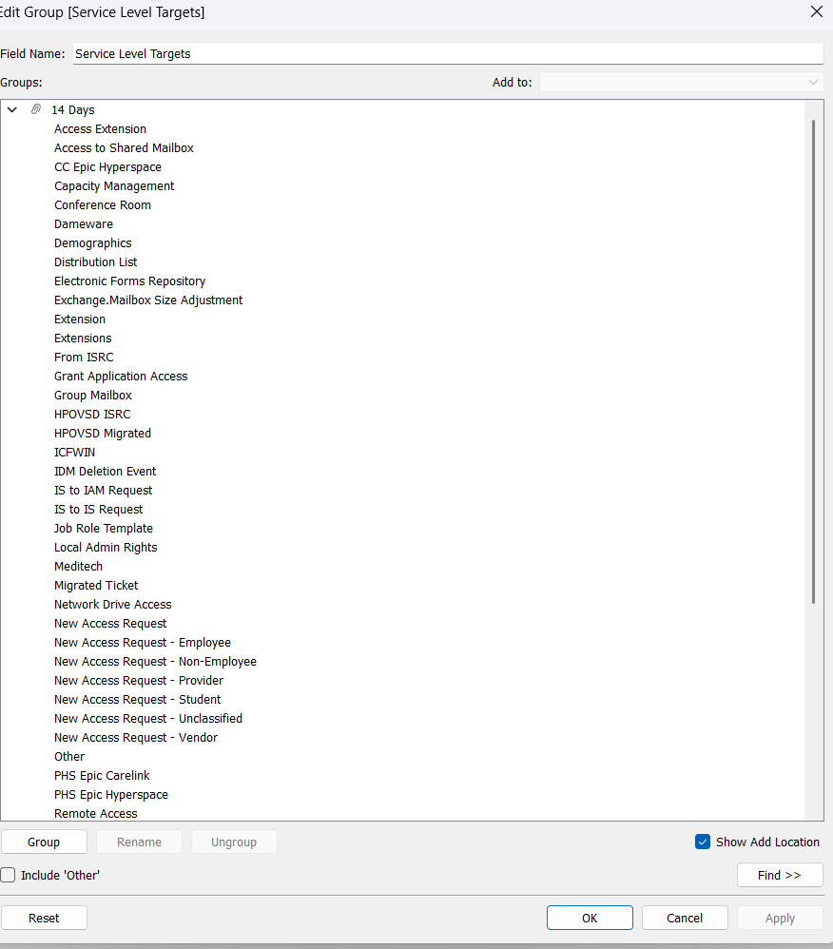

  - Below is the 1 Day values
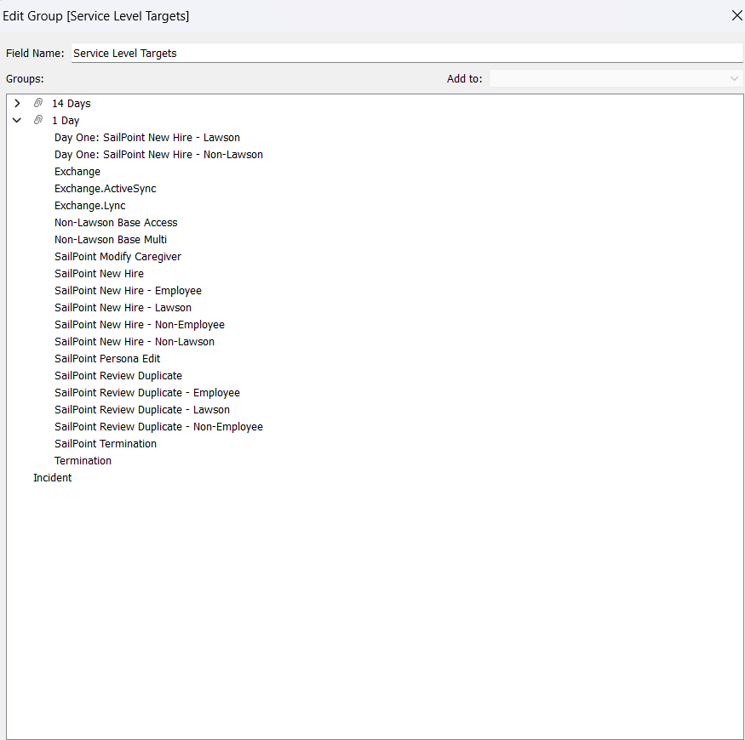

  - In Power BI we have tired to replicate the same to create the Service Level Targets by grouping the Request Area Detail Master column but we were unable to get the same values in Power BI. Below are the values of days, 14 day, and we were unable to get the Incident value.
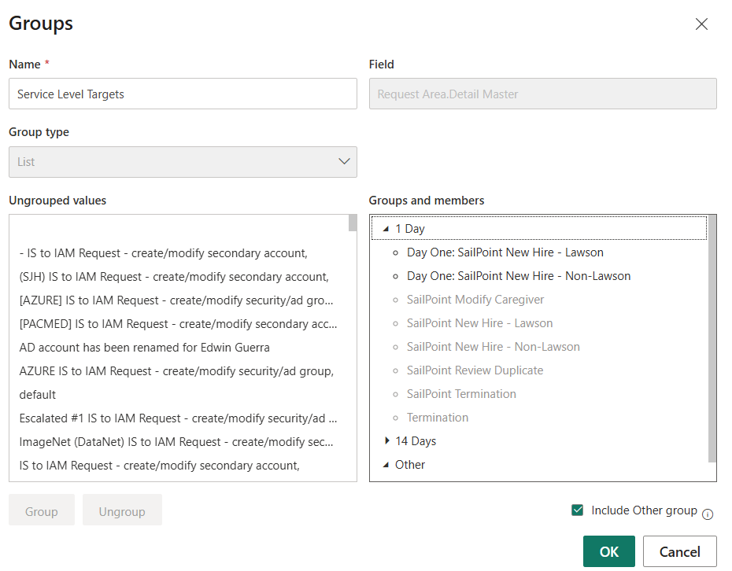
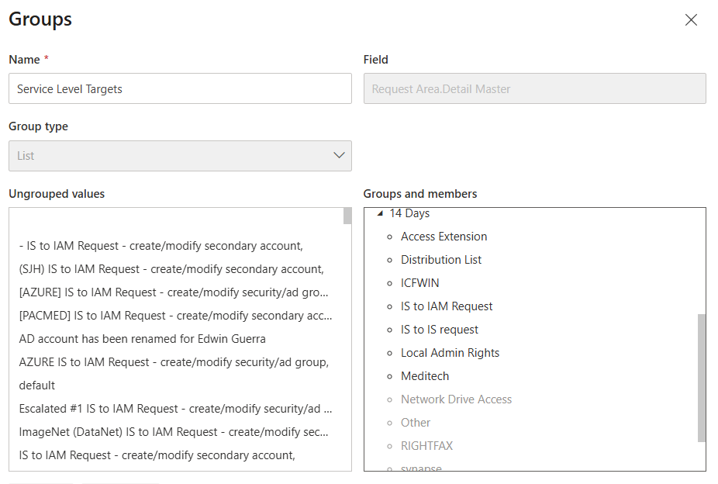
- Impact:
  - Deviation or discrepancy in Data
- Workaround / Resolution:
- We have workaround and have created a Service Level Target column where we have consolidated all other columns like Request. Area Detail Master, Request Area, and IAM Work Categories.
Created another grouping column called Service Level Target (group)_2 which is based on service level target where I have grouped as many as values in the given data

